Remote CodeCoverage reports are not printed to console HTML report generated in coverage

Also, you can see HTML-report under the tests/codeception/_output/coverage directory:

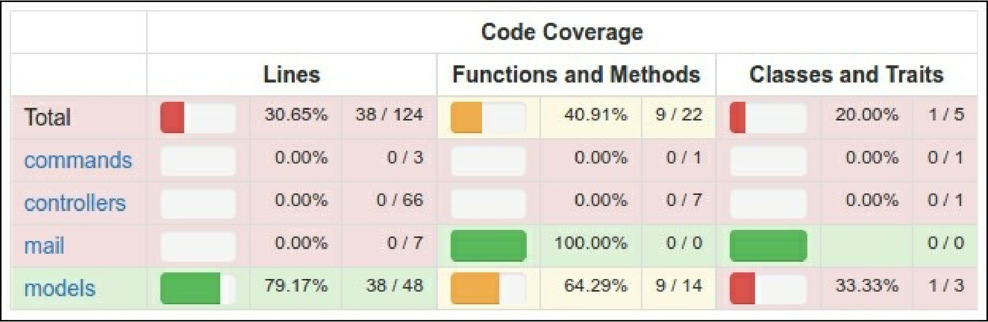

You can click on any class and analyze which lines of code have not been executed during the testing process.

Running acceptance tests

In acceptance tests you can use PhpBrowser for requesting server via Curl. It helps to check your site controllers and to parse HTTP and HTML response codes. But if you want to test your CSS or JavaScript behavior, you must use real browser.

Selenium Server is an interactive tool, which integrates into Firefox and other browsers and allows to open site pages and emulate human actions.

For working with real browser we must install Selenium Server:

1. Require full Codeception package instead of basic:

composer require --dev codeception/codeception composer remove --dev codeception/base

1. Download the following software:

° Install Mozilla Firefox browser from <https://www.mozilla.org> o Install Java Runtime Environment from <https://www.java.com/en/download/>

° Download Selenium Standalone Server from <http://www.seleniumhq.org/download/>

° Download Geckodriver from <https://github.com/mozilla/geckodriver/releases>

1. Launch server with the driver in new terminal window:

java -jar -Dwebdriver.gecko.driver=~/geckodriver ~/selenium-server-standalone- x.xx.x.jar